How to Create Courses- Once you have signed up and entered the site, visit the top of the site where it says “Courses” and click on “Create”. Fill out the information for your class.
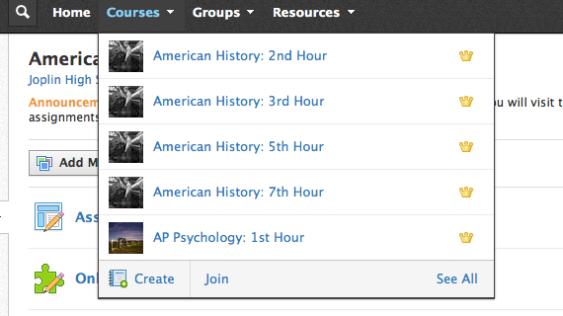
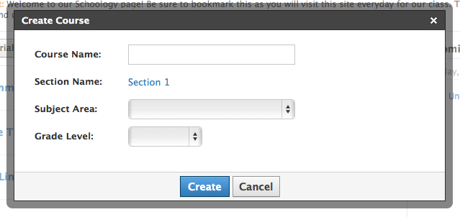

Having students sign-up for the course- Students who do not have a Schoology account will sign-up by choosing student. Students will then be asked for an access code which you can find on the page of the course you created. If they are a 11/12 student, they will choose 11/12 Campus for their building. If they are already using Schoology for another class, they will login and go to courses and select “Join” and use the same access code.
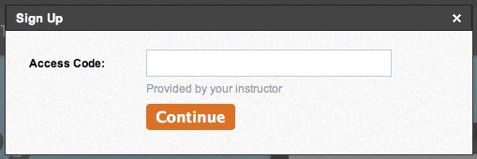
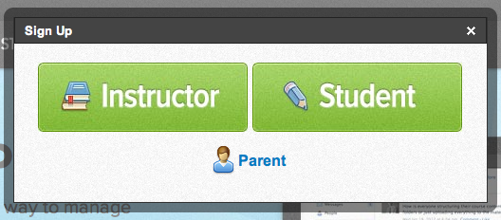

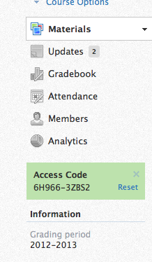
How to Add Materials to the Course:
When you login in to your home page, it will look similar to the newsfeed you would find on a Facebook page. Students will see the same thing. Choose the course you wish to work on and you will find a menu with various selections.
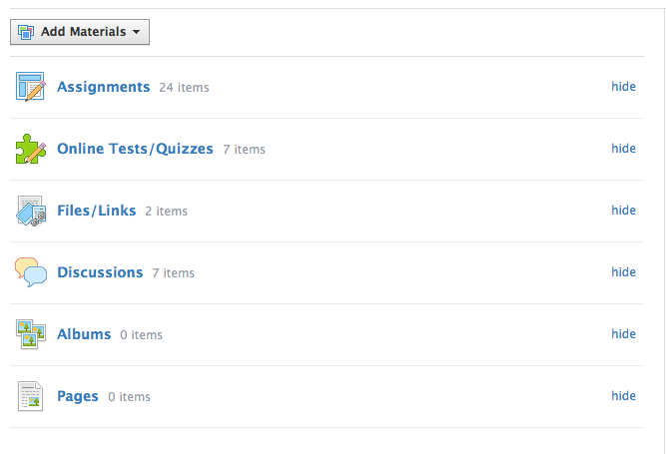

When making a new assignment, you are able to upload documents, links, add descriptions, and place the due date. You can also copy your assignments to other classes that may be the same. Students will also be able to digitally submit that assignment to you.
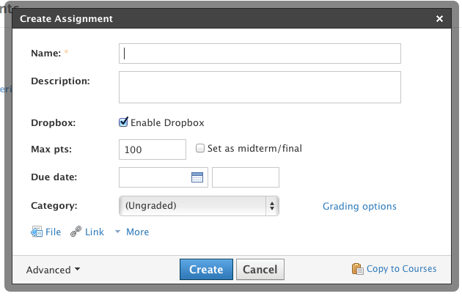

For more advanced instructions, feel free to e-mail me

atravis@joplin.k12.mo.us

